Application form 2022/23

First name: Click or tap here to enter text. Last Name:Click or tap here to enter text.
Phone:Click or tap here to enter text. Email:Click or tap here to enter text.
Website: Click or tap here to enter text.
Applying on behalf of a Group ☐ Organisation ☐ Solo ☐ Name of Group/Organisation: Click or tap here to enter text.
PROPOSAL
Exhibition title: Click or tap here to enter text. Have you displayed with us before? Yes ☐ No ☐
Summary
A clear and concise description of the body of work to be featured in the exhibition, including artform, materials and technique, and an outline of the exhibition’s overall themes and context.Click or tap here to enter text.

Content
Please include estimated number of works, further details on materials and technique, and any specific requirements for installation and display. Click or tap here to enter text.

Themes, context and relevance
Please provide further details on the themes and subjects explored by your work; any relevant major influences or movements, and indicate how your work may be received by the Gallery’s audiences. Click or tap here to enter text.

Experience
Please note previous exhibition history, relevant educational details, and publications or reviews.
Click or tap here to enter text.

Public engagement activities If you would like to deliver any public programs (e.g. artist talks, workshops, performances) in conjunction with your exhibition, please provide details.
Click or tap here to enter text.
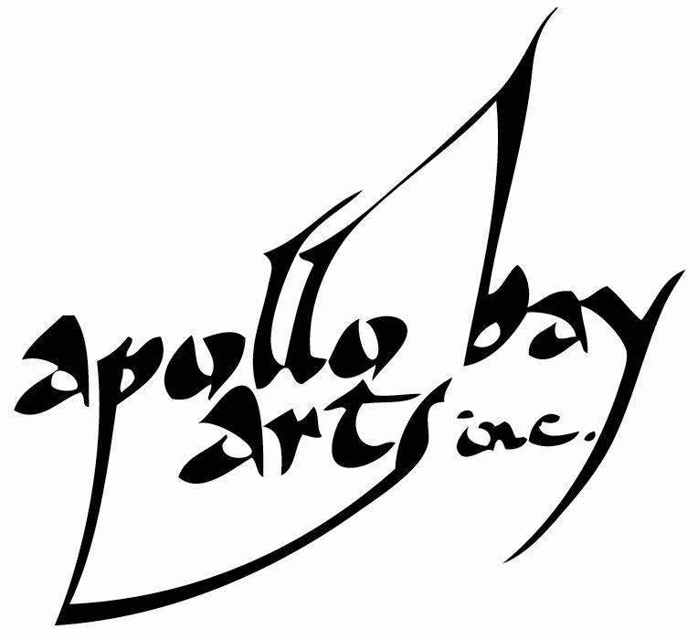
1 Supported by Apollo Bay Arts Inc. ABN: 44742259442 email: artsincgallery1@gmail.com 21 Great Ocean Road, Apollo Bay, VIC 3233

PREFFERED DATES

Please check your preference:
☐ Dec- Jan- Feb ☐ June- Jul- Aug ☐Specific Dates: Click or tap here to enter text.
☐ Mar- Apr- May ☐ Sep- Oct- Nov
Length of show: Click or tap here to enter text. | Note: Hire period is inclusive of installation and de-installation time.
Dates are not guaranteed, we will endeavour to negotiate show dates within your preferred bracket or specific dates.
DECLARATION
I / we have read the Arts Inc. Gallery 2022-23 Exhibition Guidelines☐ and Code of Conduct. ☐ ☐
I/ We understand and accept the conditions of exhibiting in the Arts Inc. Gallery. ☐
Name*: Click or tap here to enter text. Date*: Click or tap here to enter text.
PRIVACY
The personal information provided in this document is protected under the Privacy Act (1988). The Privacy Act provides for the protection of personal information, and for the privacy of individuals. Arts Inc. Gallery will not disclose your personal information to any person or body unless required by law to do so or if it is directly related to the purpose for which the information was collected.
Note: * required field
IMAGES AND SUPPORT MATERIAL

A minimum of 8 high quality digital images must be submitted with your proposal. The images must be high resolution and should demonstrate your current work and the concept within your proposal. Images should be indicative of the proposed exhibition work.
If you are including new media content in your support material, please provide viewable file formats or include a URL address link to high quality content on a hosting website.
All support material should in digital format, and will not be returned, please do not send original materials.

Please email your completed application and signed Code of Conduct form to artsincgallery1@gmail.com We will endeavour to reply as soon as possible. If you have any questions please feel free to ask.
2 Supported by Apollo Bay Arts Inc. ABN: 44742259442 email: artsincgallery1@gmail.com 21 Great Ocean Road, Apollo Bay, VIC 3233

